The professor’s parents are under the impression that it rains too much in Seattle (SEA). Said parents live in St. Louis, MO (STL), so we used data science methodology to construct a way to conceptualize and test their belief. We pulled climate datasets from the National Centers for Environmental Information (NOAA Climate Data) for the cities of Seattle, WA and St. Louis, MO from January 1st, 2017, to December 31st, 2022. By gathering climate data from both cities, Seattle, and the city where the parents live (St. Louis), we now have a way to use comparison to check their assumption. The question to address the issue was then neatly proposed: can we use the data to determine whether it rains more in Seattle or in St. Louis. By answering this question, we can address the parents’ belief that it rains too much in Seattle.

The Seattle climate data was sourced from only one weather station, and it contained climate data only from 2018 to 2022, whereas the St. Louis dataset contained climate data from multiple weather stations, spanning from the years 2017 to 2022. Therefore, we took a subsection of the St. Louis dataset, pulling data only from the St. Louis Lambert Int’l Airport weather station, starting from 2018. The datasets were then merged together, making sure that all dates were kept. Missing values were then checked for, and all replaced with the mean precipitation for that date across all 5 years.

In order to begin addressing the question of whether it rains more in Seattle or St. Louis, a few questions about the data were proposed and modeled. First, we looked at a subset of the data that contained a count of days for which each city recorded no rainfall, over the 5-year span. The number of days for each city were plotted on a bar plot, with about 1200 total days absent of rainfall were reported for St. Louis, while about 800 days without rain were reported for Seattle (See *Fig. 1*).

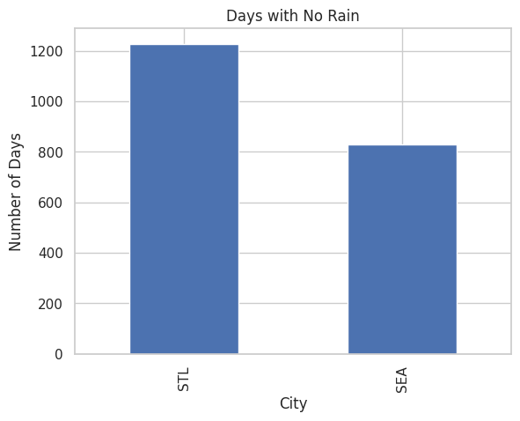*Fig. 1:* Bar plot displaying number of days without rain for STL & SEA.

There were about 400 more rainless days in STL than in SEA, meaning that Seattle had more days with recorded rainfall. Next, we looked at a subset of the data that contained a count of days for both cities where at least 1.5 inches of rainfall was recorded over the 5-year span. This was also visualized in a bar plot (not pictured), where STL had 27 recorded days with 1.5 inches of rain, and SEA had 11 reported days. Finally, the average monthly precipitation for each city over the 5 years was plotted onto a bar chart (See *Fig. 2*).

*Fig. 2:* Bar plot displaying average monthly precipitation for each city during the 5 years.

This visualization indicates that St. Louis tended to have higher recorded average monthly rainfall levels than Seattle.

Overall, the plot that displays the total number of days for each city in which no rainfall was recorded indicates that the city of Seattle has more actual days where it was raining (days where precipitation was recorded). On the other hand, though, the city of St. Louis had overall heavier recorded rainfall levels. This means that precipitation was recorded to have fallen on the days where it actually rained there, as compared to Seattle. So, to answer the question if it rains more in Seattle than St. Louis, even though there were less rainy days recorded in St. Louis than in Seattle, the days where it did rain in St. Louis experienced more rain during those times.